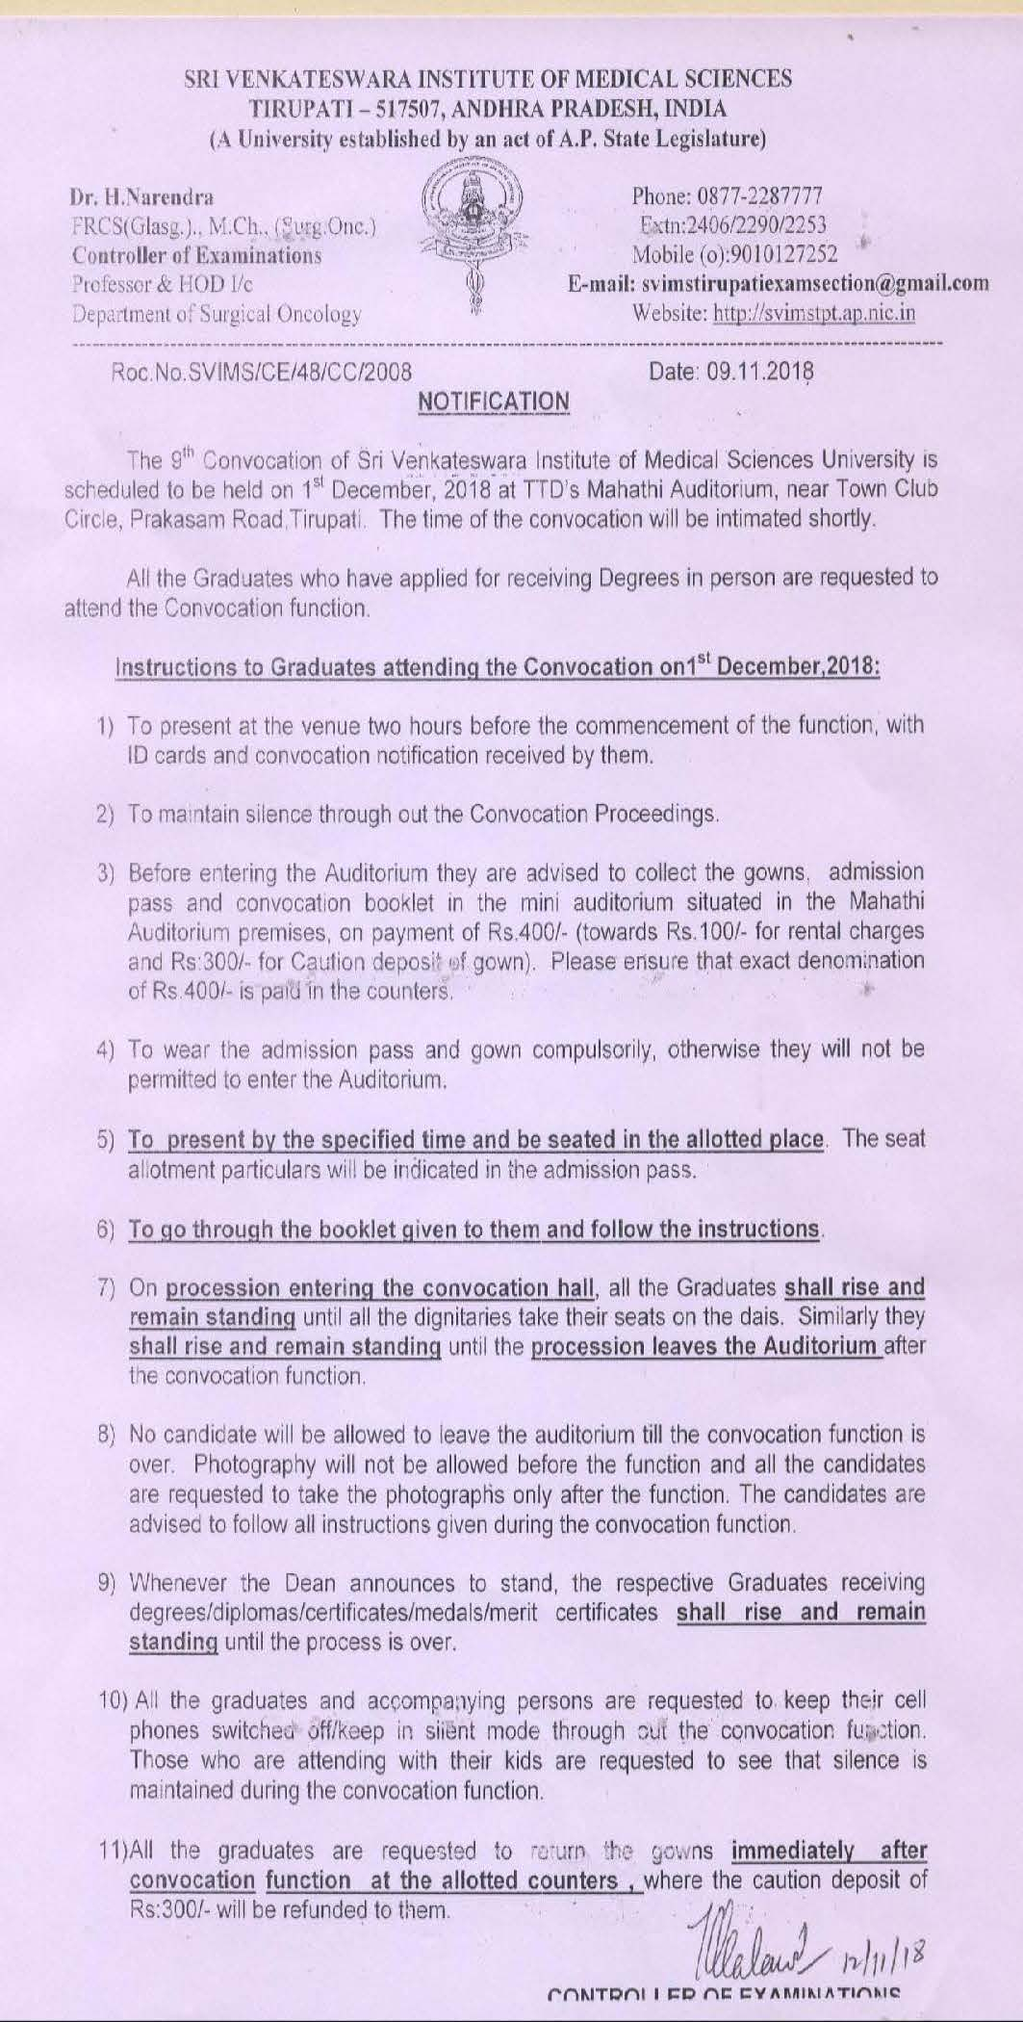

SRI VENKATESWARA INSTITUTE OF MEDICAL SCIENCES, TIRUPATHI
APPLICATION FORM FOR AWARD OF PERMANENT DEGREE CERTIFICATE

NOTE: The spelling as written in the Provisional Pass Certificate shall be followed in the Degree certificate. Request for change of spelling will not be entertained unless specific reasons along with proof are submitted. Those who have not taken the Provisional Pass Certificate are not entitled to receive the Permanent Degree Certificate unless they fulfill all the formalities.

1. Name of the student :
(Please write in block letters)

2. Father’s name :
(Please write in block letters)

3. Course Studied :
4. Period of Study :
5. Month and year of passing :
6. Reg. Number :
7. Complete Permanent address :
( Please indicate pin code compulsorily)

8.Phone numbers : Landline :
(Indicates STD code)
Cell Phone:
E.Mail ID:
9.Fees paid particulars : Demand Draft/Chelan No._________
Date: ___________
Drawn on: ___________
Amount: ___________

__ ___________________
Signature of the Candidate

Enclosures: 1) Demand Draft
2) Xerox copy of Provisional Degree Certificate
3) One latest passport size photo, kept in a separate cover
4) Adharcard Xerox

